PRACTICAL -3

OBJECTIVE- CREATE AN S3 BUCKET IN AWS

**1. Log in to AWS Management Console**

* Go to AWS Console.
* Sign in with your AWS account credentials.

**2. Navigate to S3**

* In the search bar at the top, type **S3**.
* Click on **S3 (Scalable Storage in the Cloud)**.

**3. Create a New Bucket**

* Click on **“Create bucket”** button.

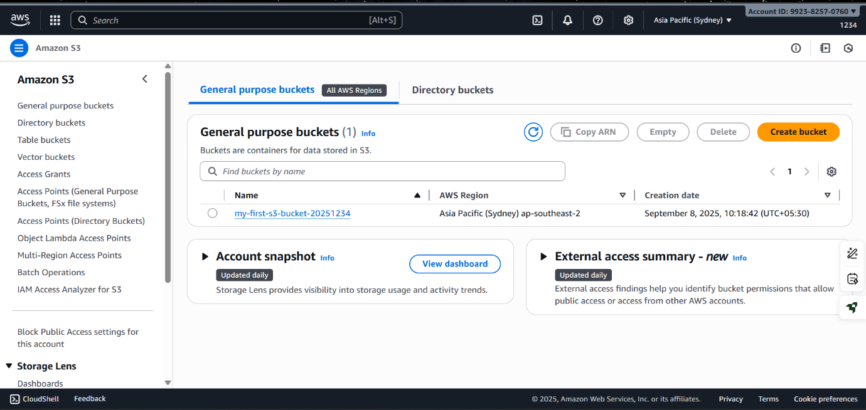

**4. Configure Bucket Settings**

* **Bucket name**: Enter a unique name (e.g., my-first-s3-bucket-2025).

Bucket names must be globally unique across AWS.

* **AWS Region**: Select a region (choose one closest to your users for better performance).

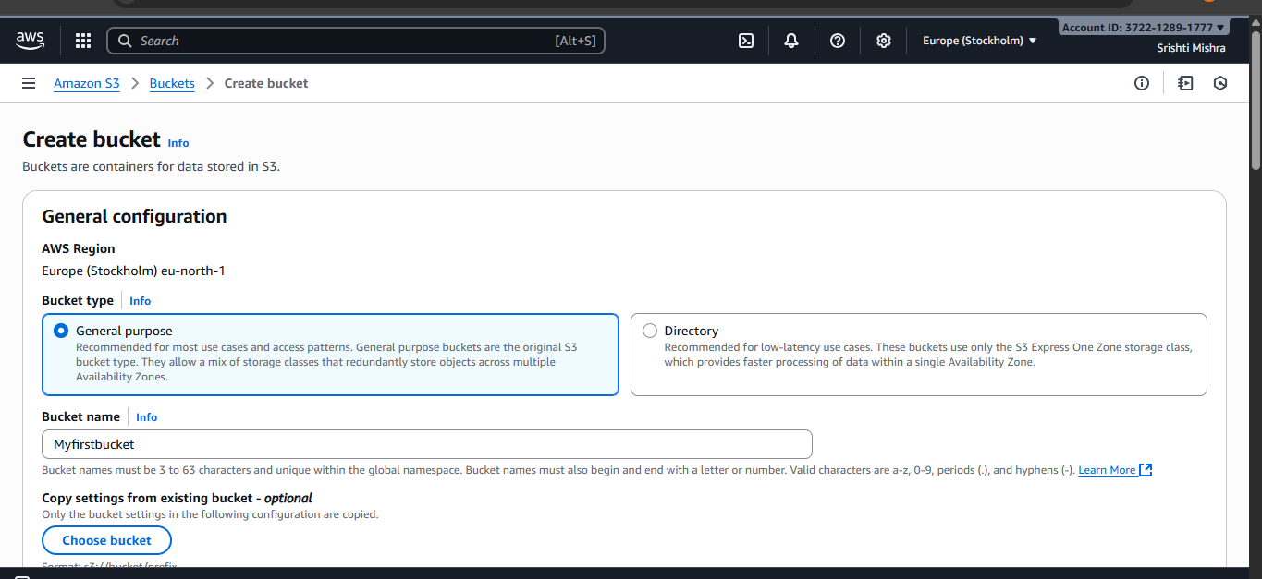

**5. Set Bucket Options**

* **Object Ownership**:
  + Choose **ACLs disabled (recommended)** for most use cases.
* **Block Public Access**:
  + By default, all public access is blocked (recommended for private buckets).
  + If you need a public bucket (for hosting static websites), uncheck the option and acknowledge the warning.

**6. Configure Bucket Settings (Optional)**

* **Versioning**: Enable if you want to keep multiple versions of an object.
* **Encryption**: Enable default encryption if required.
* **Tags**: Add key-value tags if you want to manage cost tracking or organization.

**7. Review and Create**

* Review your settings.
* Click **Create bucket**.

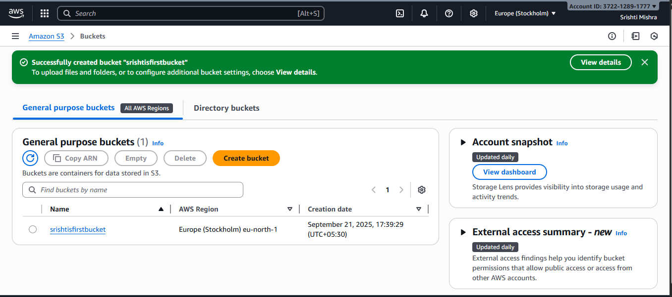

**8. Upload Objects (Optional)**

* After creation, open the bucket.
* Click **Upload → Add files**.
* Select your file(s), then click **Upload**.

